Week 2 – The Weimar Republic:
Source 1 – An extract from the Weimar Constitution (August 1919) – Article 48:

Article 48: If any state does not fulfil the duties imposed upon it by the constitution or the laws of the Reich, the Reich President may enforce such duties with the aid of the armed forces. In the event that public order and security are seriously disturbed or threatened, the Reich President may take the measures necessary for their restoration, intervening, if necessary, with the aid of the armed forces. For this purpose he may temporarily suspend, wholly or in part, the basic rights laid down in Articles 114, 115, 117, 118, 123, 124, and 153. The Reich President must without delay inform the Reichstag of all such measures…

Source 2 – Cartoon published in German newspaper ‘Simplicimus’ on 3 June 1919 depicting the leaders of France, Britain and the USA and a figure representing Germany with hands tied:
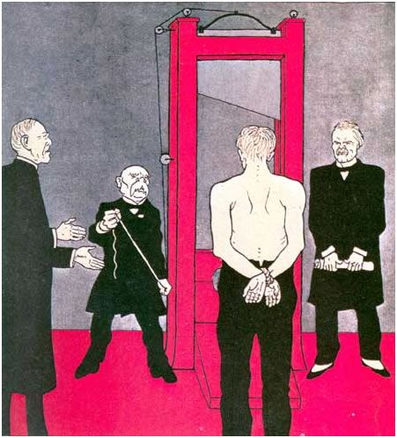

- Explain the message of Source 1.
The message of Source 1 is that if the President of the Weimar Republic feels that the state is not fulfilling its duties or there is some kind of emergency, he can step in and do so himself to restore order using the aid of the armed forces. Further, the source states that in doing this, the President can temporarily suspend the rights and freedoms laid down in the Constitution in Article, 114, 115, 117, 118, 123, 124 & 153.

- Explain the historical context of Source 2.
Source 2 relates to the Treaty of Versailles and what Germans felt and though about it. Although they launched a do or die offensive in early 1918, the Germans knew they could not win the First World War by September 1918 and were forced to sign an armistice in November 1918. Although they hoped to then negotiate peace terms with the Allied nations of France, Britain and the USA, they were largely ignored in the negotiations and the final Treaty was very harsh towards Germany. Germany was deemed colonially unworthy and had its colonial possessions taken from it. It was forbidden from having an air force, submarines or an army over 100,000 troops. Land was taken from East Prussia for the so-called Polish corridor. The Treaty also contained a clause stating that Germany must take responsibility for starting the conflict and subsequently Germany would be forced to pay reparations for the damage caused in the war. This cartoon was published prior to the final signing of the Treaty and shows how people in Germany believed that it would destroy the country by depicting the figure of Germany about to be beheaded by the victorious Allied powers.

- Identify and discuss the author’s perspective in Source 2 regarding the Treaty of the Versailles.
The author’s perspective regarding the Treaty of Versailles is that it will kill Germany and the Allied powers are being unnecessarily harsh. The reason for this perspective is that author was a German and it was published prior to the final signing of the Treaty in late June 1919. The vast majority of Germans were angered by the Allied powers and the Treaty and saw it as a diktat (dictated) peace and far too harsh. As such, the author is representative of broader German opinion. The Germans too actually were largely ignored by the Allied nations and there was no real negotiation, hence the depiction of the German as being helpless and tied up.

